|  |
| --- |
| **National University of Computer and Emerging Sciences** |
| In Lab Exercise 5 “Aggregation-Grouping, Nested Queries, Set Operations” |
|  |
| Database Systems |
| Spring 2018 |

Department of Computer Science

FAST-NU, Lahore, Pakistan

# Exercise

For this exercise use the following schema, the script to create this schema and populate data is given in ATM.SQL file

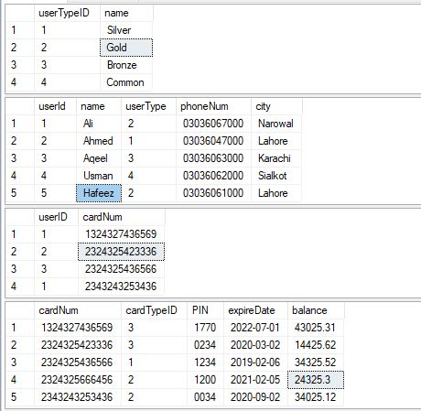

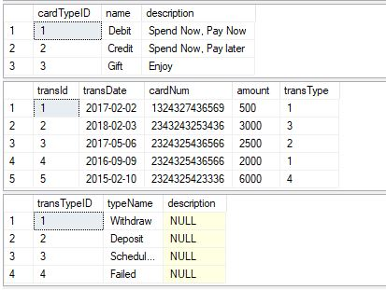

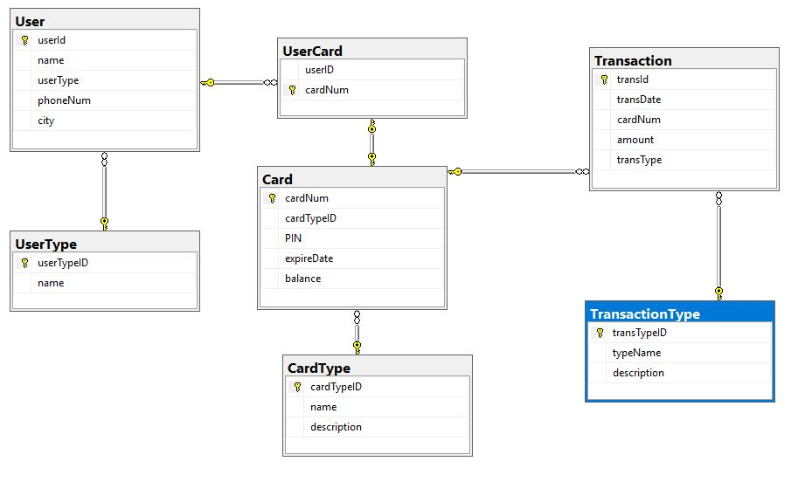

1. List the names of the users who are from same city. (Use Self Join)

# Aggregation-Grouping

1. List the number of users in each city.
2. List the number of users in each city, sorted high to low.
3. List the name and number of cards **for each user**, sorted low to high.
4. List the Card numbers and number of transactions against each card number **having** more than two Transactions.

**Nested Queries**

1. List the card numbers, not used for transaction. (Hint: Exists)
2. List the name of the user who has maximum balance in the card (One person can have more than 1 card, check only for one card which has max balance).

**Set Operations**

1. List the users who are not gold type. (Hint: Except)
2. List the userId and name of the users whose cards are not expired.
3. List the Users details who are **gold type** and **common type.**  (Without using AND operator and join)